**AVR-ISP Bread Board Adapter Rev. 0**

**Test Description**

# Setup

* AVR-ISP Adapter Rev. 0
* Bread board
* A minimum Arduino UNO circuit wired up on the bread board
* Diamex USB ISP-Programmer (Atmel AVR)
* Arduino IDE (v2.0.4)

# Execution

The circuit as shown in the schematic doc.-no. 106-1-02-00 was wired up on the bread board. The programmer was set to output 5V supply voltage for the connected circuit.

The AVR-ISP adapter was connected to the bread board and wired up with the ATmega328P processor.

**The adapter fit into the bread board without a problem.**

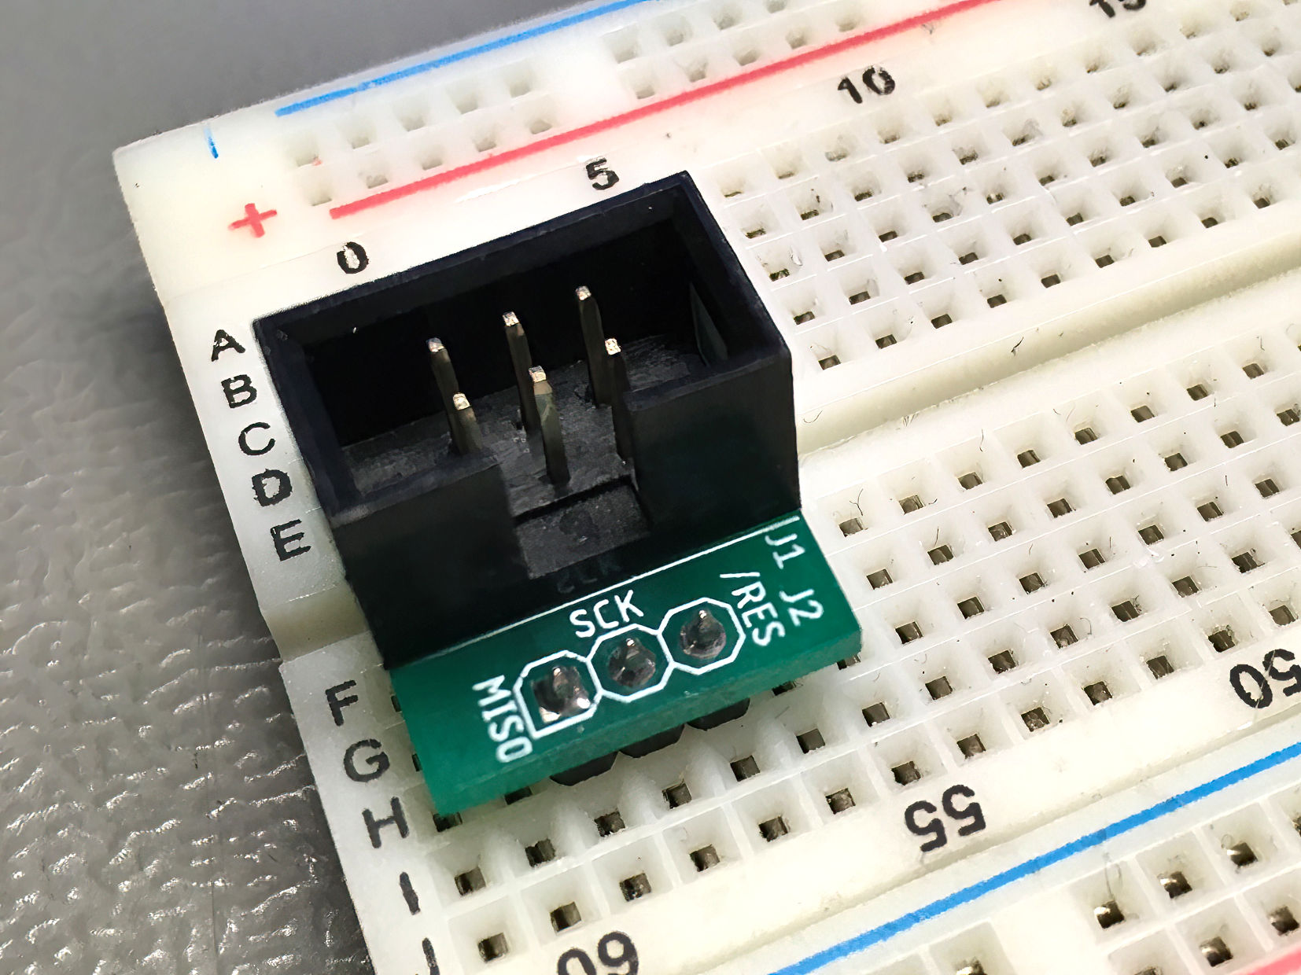

Figure 1: The AVR-IS adapter connected to a bread board

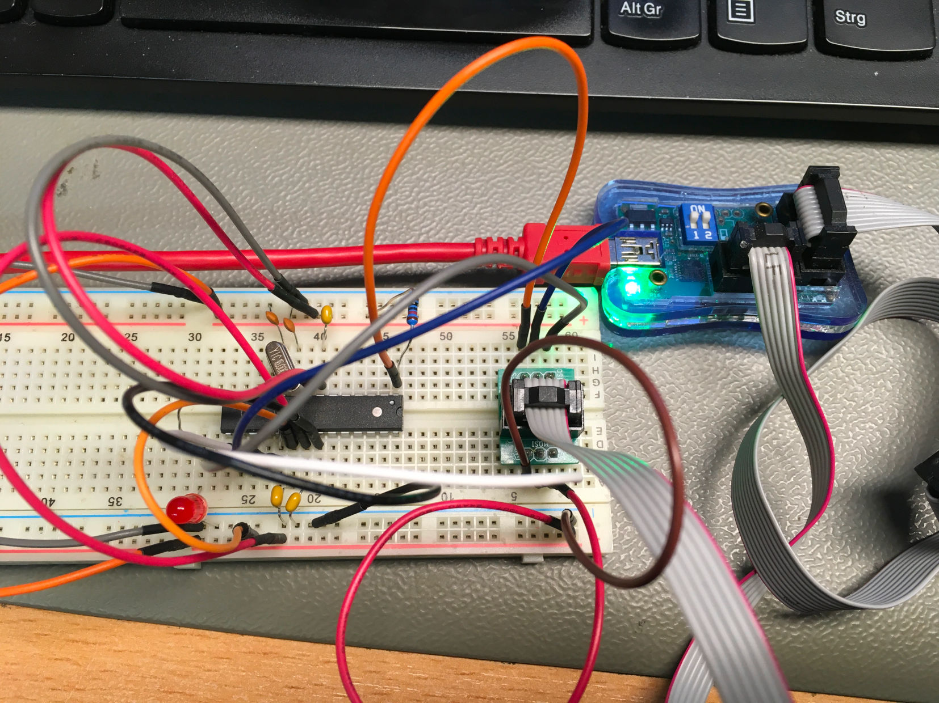

Figure 2: The test circuit wired up on the breadboard , programmer connected

The programmer type (STK500) was selected in the Arduino IDE (Tools→…). The port for the programmer was selected. The board type (Arduino Uno) was selected.

Now, the boot loader for Arduino Uno was programmed (Tools→Burn Bootloader). This **worked without complains**.

Finally, the blink_led13 sketch was programmed via the programmed (Sketch→Upload using programmer). The **programming worked out without complaints**. The LED started blinking.

# Conclusion

**The AVR-ISP adapter Rev. 0 is fully functional.**